Question1:
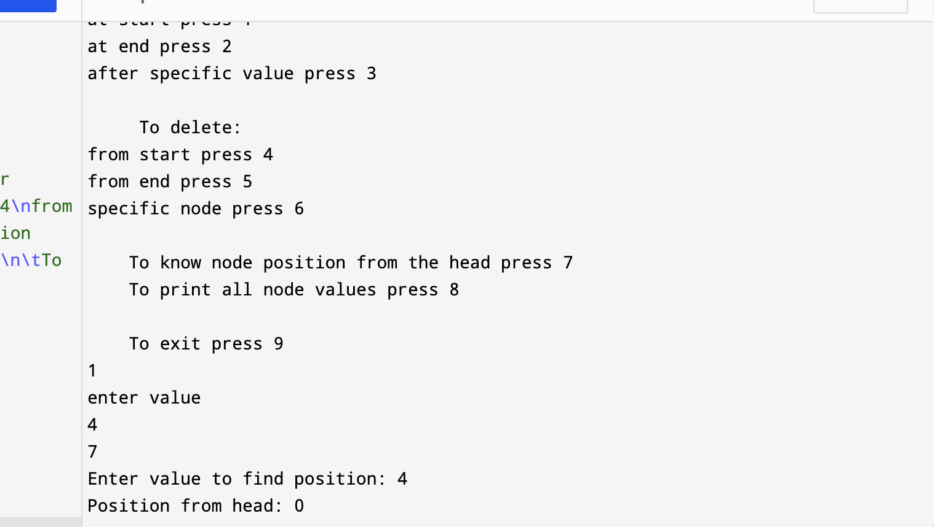

Question2:
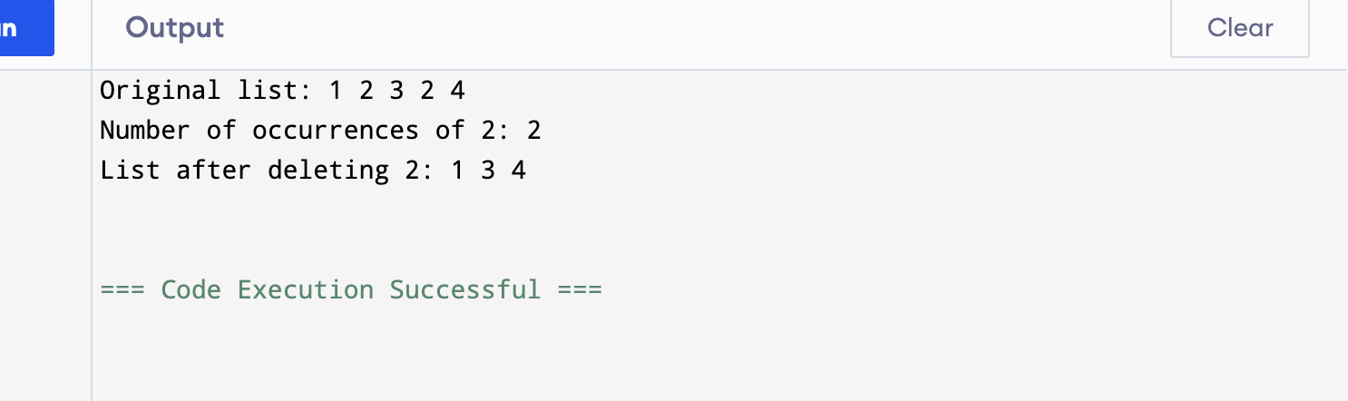

Question3:
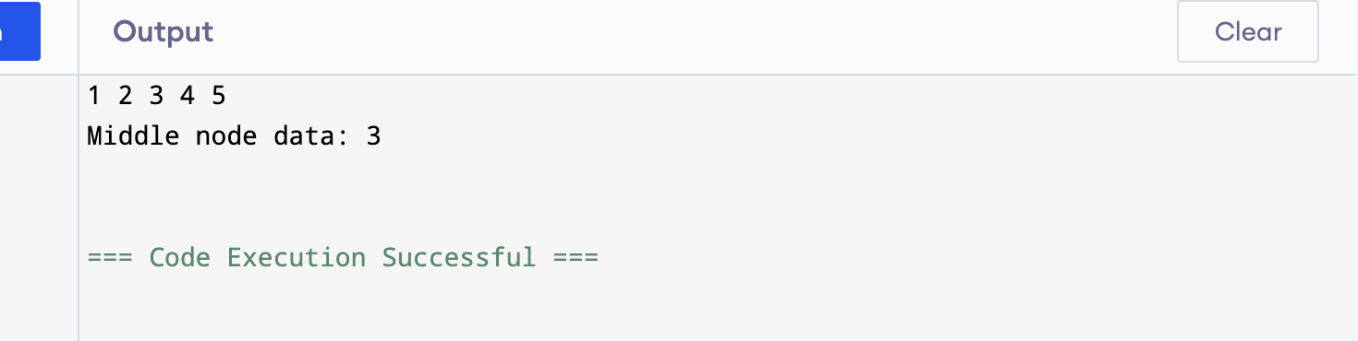

Question 4:
